## Report

## Q 1. Provide the knowledge-base of ALL courses for ALL members of the team

## Please find the attached file, named “schedule-40029586.pl”, which contains the required information.

## Q 2. Run the following query and report the result:

After running the query following response is generated.

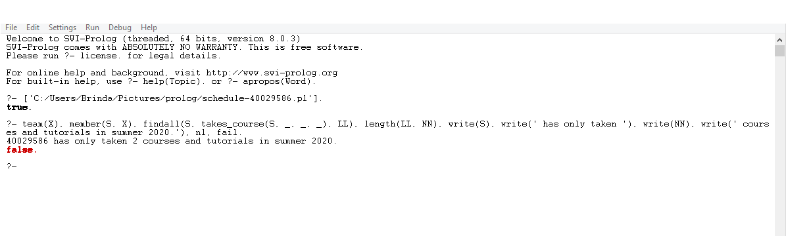

## Q 3. Create below mentioned rules to query the designation information from your knowledge-base.

## Please find the attached file, named “q3_rules.pl”, which contains the required implementation of rules.

## Q4. Modify the code in Q2 to count only the courses regardless of their sections (i.e. comp 348 aa and aaae will be counted as one).

Modified query of Q2 is (changes are in bold and highlighted)

team(X), member(S, X), **setof**(S, takes_course(S, _, _,_ ), LL), length(LL, NN), write(S), write(' has only taken '), write(NN), write(' courses and tutorials in summer 2020.')**, !.**

***As a result output is*;**

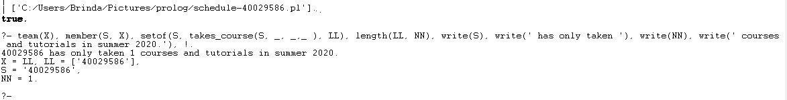

## Q 5. Compare the result for all_courses2('4000123', L) vs. all_courses2(4000123, L). Explain the difference.

In first case **all_courses2('4000123', L)** the value of student id is taken as string as a result output is

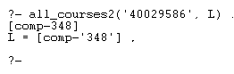

In second case **all_courses2(4000123, L).** the value of student id is taken as number (integer) as a result output fails as shown

